Waste management and health protection strategy
Primary school „Vladimir Nazor“ Ploče

Smart Waste Management for Smarter Cluster Schools
Pr. broj: 2020-1-RO01-KA229-079971_4

We have placed waste disposal bins at our school (see picture below).
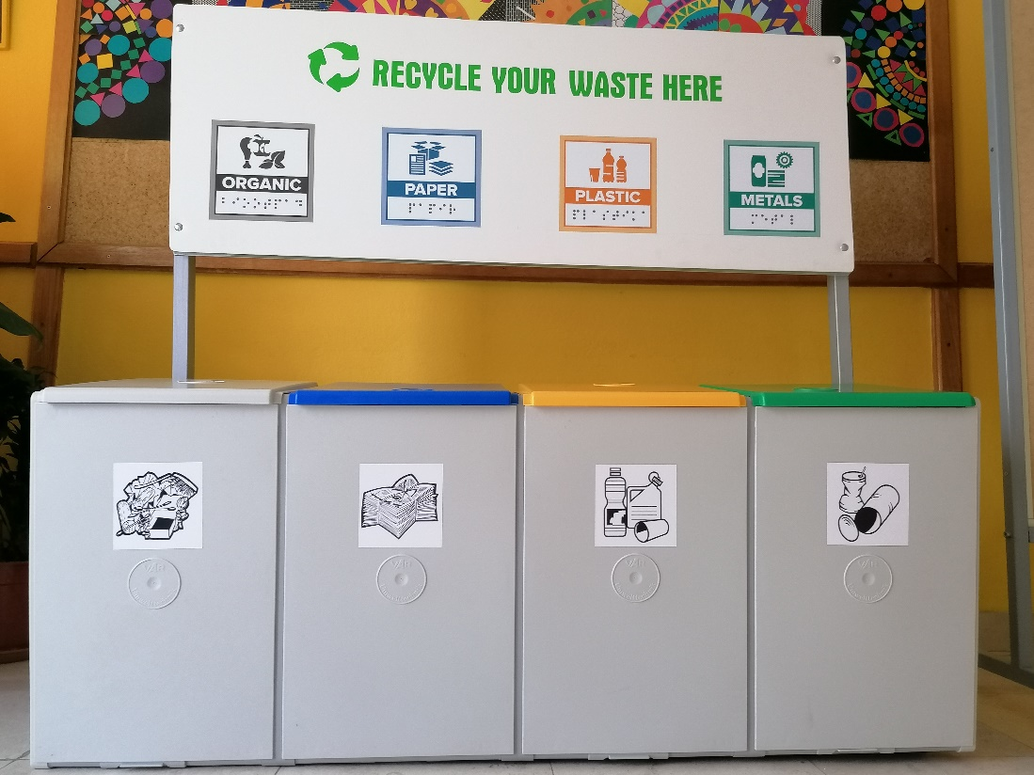

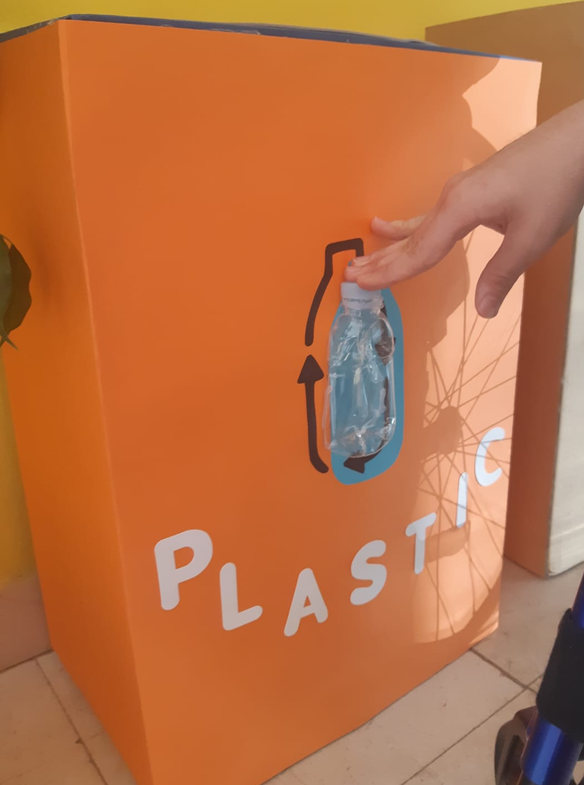
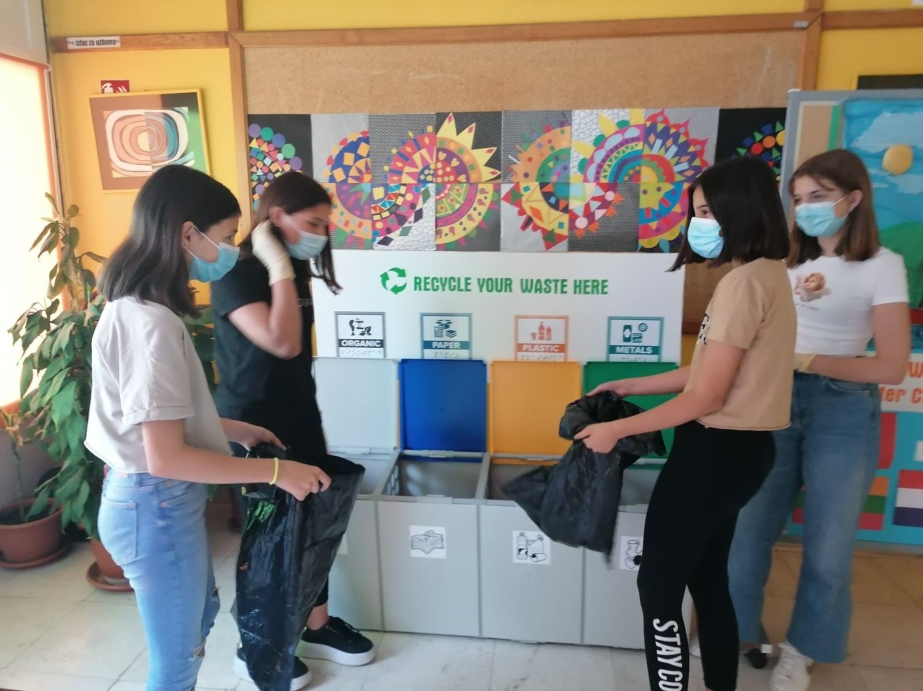
Paper is carried away to larger designated city containers once a week, plastic is taken away by utility company also once a week, metal is disposed into city containers every two weeks and bio-waste is used as compost every day.
Sanitary requirements are met when bins are being handled. They are disinfected daily and, while doing so, gloves are worn.
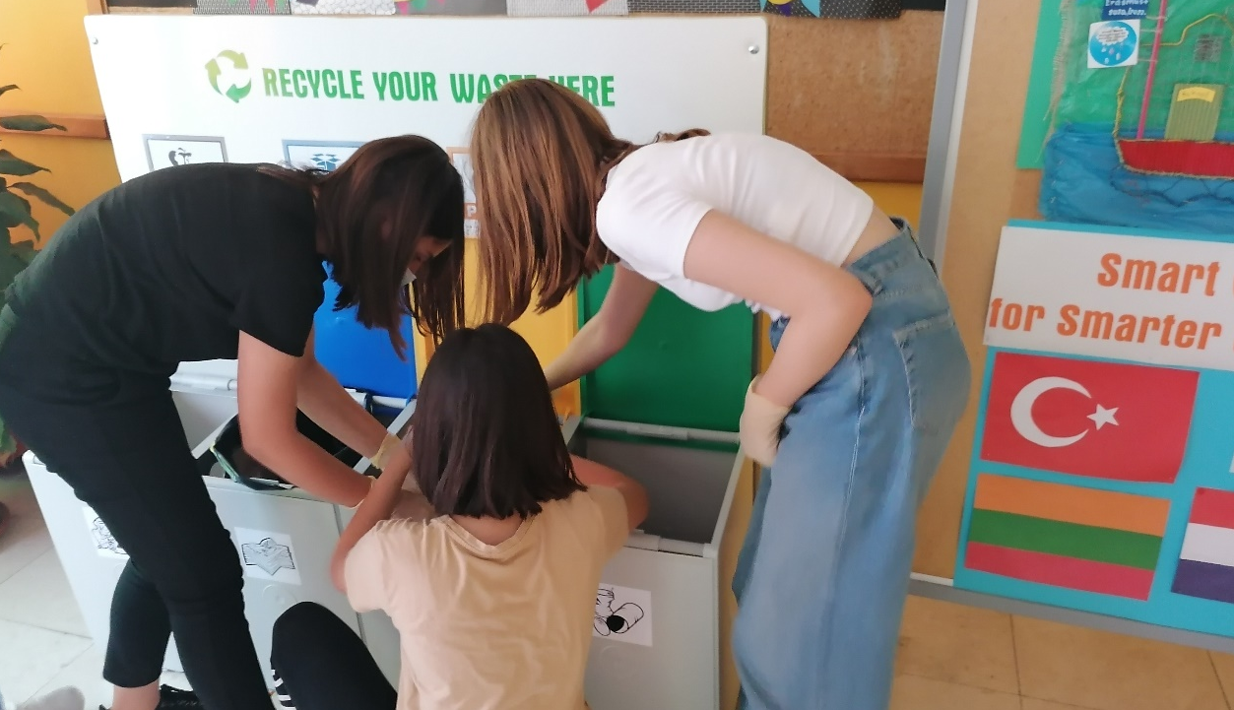

Table below states the amount of specific waste for determined time periods.
WEEKS | PLASTIC ( kg) | METAL (kg) | BIO WASTE (kg) | PAPER (kg)
3.5.-7.5. | 0,9 | 0,3 | 3,4 | 12,7
10.5.-14.5. | 1,1 | 0,4 | 3,7 | 10,3
17.5.-21.5. | 0,8 | 0,4 | 2,8 | 8,4
24.5.-28.5. | 1,6 | 0,6 | 5,2 | 15,6
SUM | 4,4 | 1,7 | 15,1 | 47,0

Percentage of PLASTIC : 6%
Percentage of METAL : 3%
Percentage of BIO WASTE : 22%
Percentage of PAPER : 69%

- Picture below represents a bar chart showing the amount of paper gathered per week during May.

This picture shows the way disposed paper is reused. We should not forget that paper takes 6 weeks to decompose in nature. If we dispose of it at designated locations, we help protect our environment.
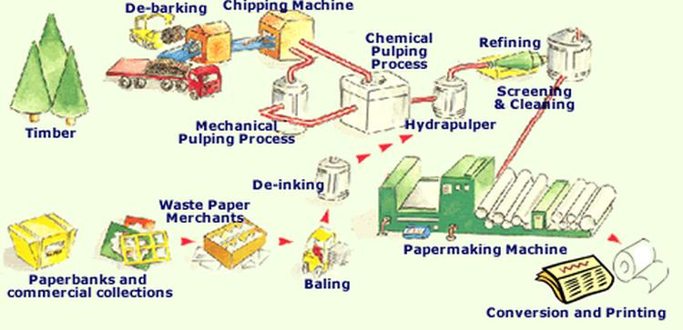

- Picture below represents a bar chart showing the amount of bio-waste gathered per week during May. Bio-waste takes 3 months to decompose in nature.

Picture below shows the use of bio-waste.
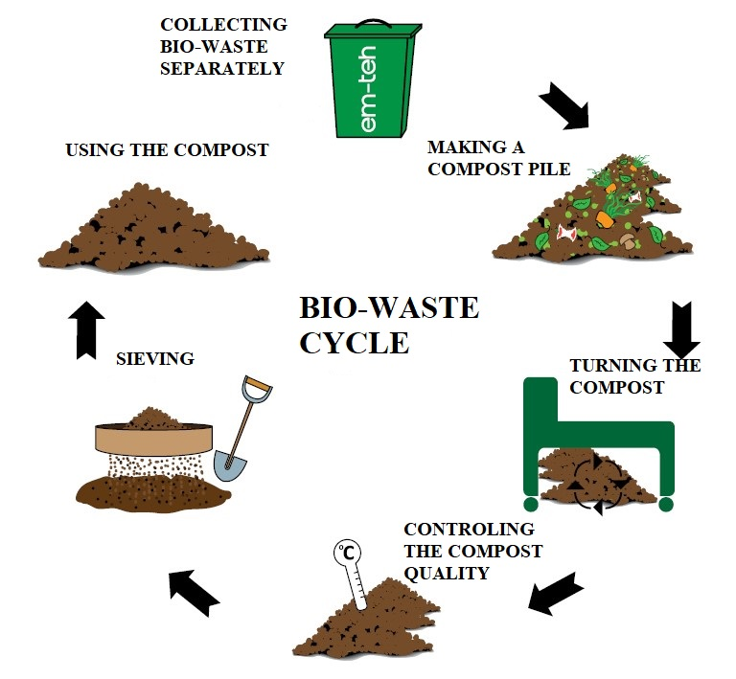
- Picture below represents a bar chart showing the amount of metal gathered per week during May. It was mostly cans and aluminium foil. A can takes 50 years to decompose!

Picture below shows the reuse of cans (metal waste).
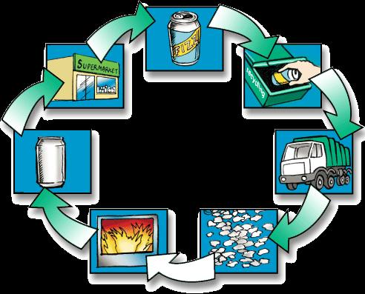

- Picture below represents a bar chart showing the amount of plastic gathered per week during May. Plastic takes up to 500 years to decompose.

Picture represents the cycle of plastic waste reuse.

